Installation & Operation Manual

Pump Controller(PCS11 PLUS-MINI)

Ver. 1.0

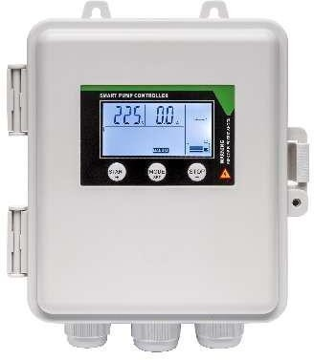

OVERVIEW
The Pump Controller(PCS11 PLUS-MINI) abbreviated to PCS is a programmable control panel that is used to protect and control pumps. Primarily deep well submersible pumps, but also centrifugal; in-line; circulation and multistage pumps. The PCS has four general operating modes namely tank to tank; booster by pressure switch; drainage by sensor; timed pumping. The PCS ’s protection features are dry run; overload; stalled pump; over voltage; under voltage;.

BUTTON & OPERATIONS
BUTTON | OPERATION [MANUAL mode unless otherwise stipulated]
START | Pump should start if not running.
STOP | Pump should stop if running.
STOP then  MODE | Display shows last five failure records.
STOP then  START | Display shows accumulative running time.
BUTTON | OPERATION OF MANUAL TO AUTO AND AUTO TO MANUAL
MODE SET | [Parameter 012 set to 00] – Manual to Auto / Auto to Manual  [Parameter 012 set to 01] – All buttons locked in Auto mode. To deactivate hold “MODE” for 5sec. Pump will then stop, and controller will switch to manual  mode.
To ensure pump and motor is protected it is essential to calibrate the controller parameters as soon as pump is running to operational standards. Perform calibration after each installation or
maintenance operation.
START | Parameter calibration:  In Manual mode press “START”, give the pump time to run as it would normally then hold “START” (approximately 5-10 sec),The controller will make a “Di” sound. The controller should now be calibrated to the current spec of the motor.
STOP | Parameter erasing:  Ensure pump has stopped running then hold “STOP” until the controller makes a “Di” sound. (Hold for approximately 5-10 sec). The controller should now be cleared of all calibrations.

SPECIFICATIONS

Main technical characteristics of controller
Control functions | Double liquid level control
Control functions | Pressure switch control
Control functions | Temperature control
Main technical data
Rated output power | Refer to label on controller
Rated input voltage | Refer to label on controller
Liquid level transfer distance | ≤200m
Protection function | Dry run | Pump stall
Protection function | Overload
Protection function | Under/Over voltage
Over voltage/under voltage recovery time | 4 minutes
Overload recovery time | 30 minutes
Main installation data
Working temperature | -25°C – +55°C
Working humidity | 20% - 90% Relative Humidity
Degree of protection | IP65
Installation position | Vertical
Unit dimensions (L x W x H) | 175*88*210 mm

Unit weight (net) | 0.8 kg

APPLICATION SETTING
Whenever the controller is to be adjusted for application the power to the controller needs to be off and only re-energized once the switches have been toggled to the desired settings.

Application | 2 Pole Switch | Description
1 | 0 0 | Tank to tank.
2 | 1 1 | Booster pump control by pressure switch.
3 | 0 1 | Drainage by level sensor.
4 | 1 0 | Timed start and stop. [Cancels out sensor terminal]

PARAMETER SETTINGS

PLEASE NOTE: Parameter settings should be adjusted after “Auto” calibration.
To access parameter settings the controller should be in manual mode and the pump should NOT be running.
Press and hold “MODE” for 5sec to enter the parameter menu.
To enter a parameter, press the “MODE” button. This will display the current value for the parameter.
To change the value, press the “START” or “STOP” buttons respectively to increase or decrease the value.
To store the value and return to the main menu press the “MODE” button.
To store all changes and exit the parameter menu holding the “MODE” button for 5 sec if yellow button is not on circuit board.

Para-  meter | Description | Range | Default value
001 | Dry run protection trip amps. |  | 0.7 times of rated running ampre
002 | Overload protection trip amps. |  | 1.4 times of rated running ampere
003 | Stall protection trip amps. |  | 1.7 times of rated running
004 | Under voltage protection trip voltage. |  | 175 V (Single Phase)
005 | Over voltage protection trip voltage. |  | 253 V (Single Phase)
006 | Dry run protection trip response time. | 0 – 254 sec | 6 seconds
007 | Dry run protection recovery time. | 0 – 254 min | 30 minutes
008 | Timer function. | 00 – 01 | 00 (Disabled) [01 Enabled]
009 | Pump running time. | 0 – 254 min | 5 minutes (Only if 008 Enabled or  dip switch at 10 position)
010 | Pump stop time. | 0 – 254 min | 5 minutes (Only if 008 Enabled or  dip switch at 10 position)
011 | Pump stop timer under manual state. | 0 – 254 min | 0 minutes (0 = inactive)
012 | LCD & button operation lock function. | 00 - 01 | 00 (unlocked) [01 locked]

POWER WIRING DIAGRAMS

Single phase input and output wiring.

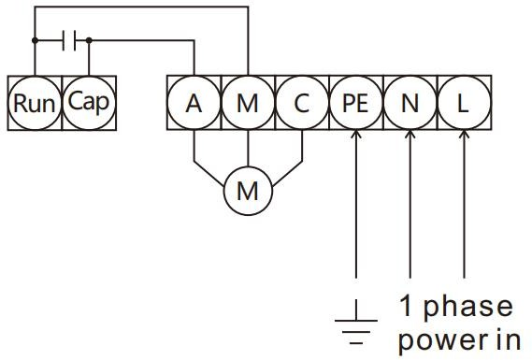

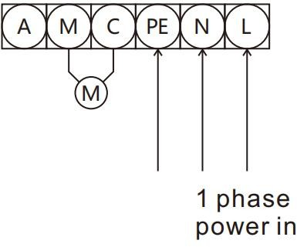

SENSOR WIRING DIAGRAMS

Factory Default wiring
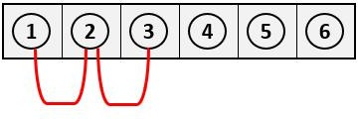

Remark:

The probe / sensor free in the water well
as the Product has reliable and automatic stop function against pump dry-run (dewatering), if it is used in submersible pump for deep well, pipeline pump or other situations when it is inconvenient to install lower liquid probe in the well, pump users can put terminals ①、②、③in short circuit, which minimize the cost .

Tank to tank.

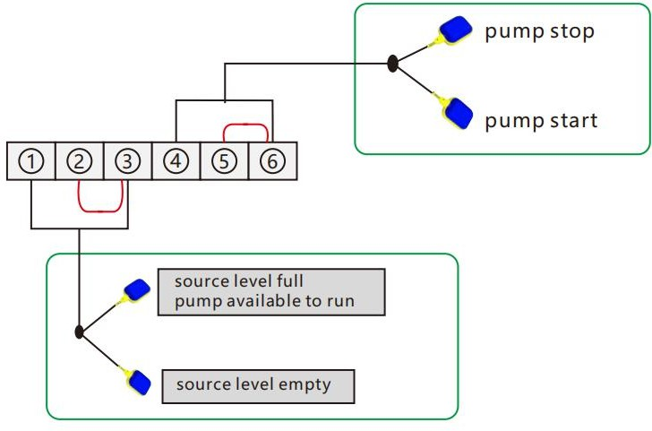
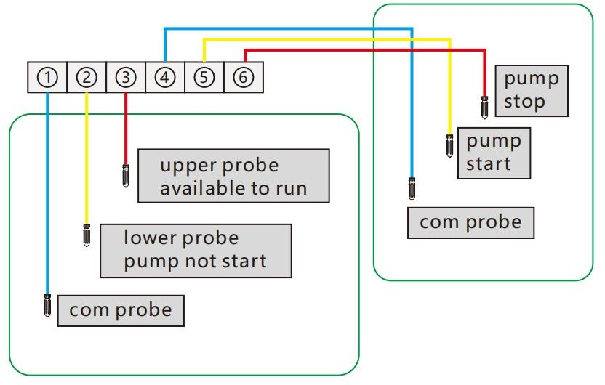

Booster pump control by pressure switch.

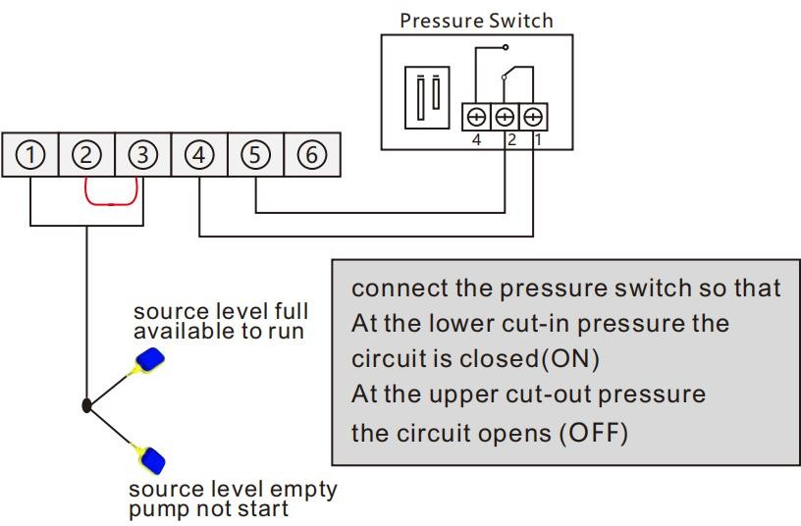

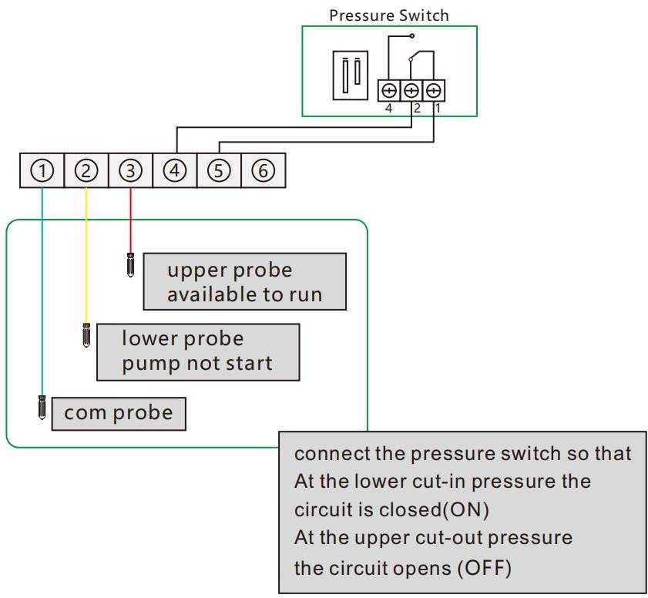

Drainage by level sensor.
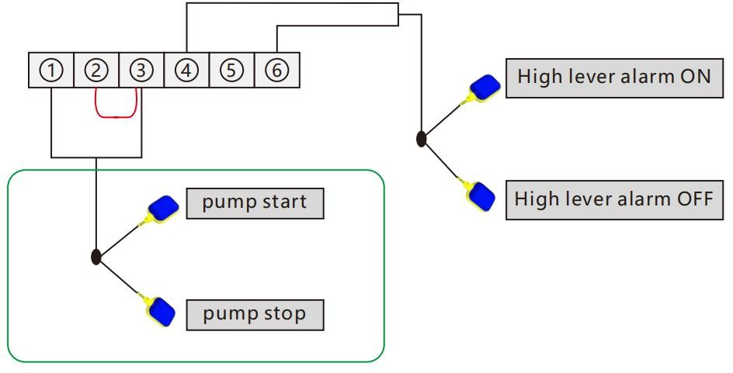

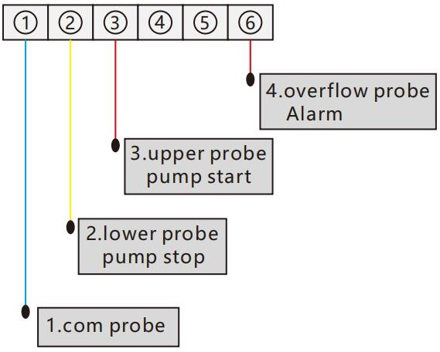

  - Smart Wi-Fi switch – dry contact

