

Installation & Operation Manual

BHC 340 (0.37Kw to 4.0Kw) Pump Controller 400V

BHC 375 (0.37Kw to 7.5Kw) Pump Controller 400V

OVERVIEW
The Bore Hole Pump Controller abbreviated to BHC is a programmable control panel that is used to protect and control pumps. Primarily deep well submersible pumps, but also centrifugal; in-line; circulation and multistage pumps. The BHC has four general operating modes namely tank to tank; booster by pressure switch; drainage by sensor; timed pumping. The BHC’s protection features are dry run; overload; stalled pump; over voltage; under voltage; open phase, phase reversal and thermal control.

BUTTON & OPERATIONS
BUTTON | OPERATION [MANUAL mode unless otherwise stipulated]
START | Pump should start if not running.
STOP | Pump should stop if running.
STOP then  MODE | Display shows last five failure records.
STOP then  START | Display shows accumulative running time.
MODE | [Parameter 011 set to 00] – Manual to Auto / Auto to Manual  [Parameter 011 set to 01] – All buttons locked in Auto mode. To deactivate hold “MODE” for 5sec. Pump will then stop, and controller will switch to manual mode.
To ensure pump and motor is protected it is essential to calibrate the controller parameters as soon as pump is running to operational standards. Perform calibration after each installation or
maintenance operation.
START | Parameter calibration:  While pump is running press and hold “START” until the controller makes a “Di” sound. (Hold for approximately 5-10 sec). The controller should now be calibrated to the current spec of the motor.
STOP | Parameter erasing:  Ensure pump has stopped running then hold “STOP” until the controller makes a “Di” sound. (Hold for approximately 5-10 sec). The controller should now be cleared of all calibrations.

SPECIFICATIONS
Main technical characteristics of controller
Control functions | Double liquid level control
Control functions | Pressure switch control
Control functions | Temperature control
Main technical data
Rated output power | Refer to label on controller
Rated input voltage | Refer to label on controller
Liquid level transfer distance | ≤200m
Protection function | Dry run | Pump stall
Protection function | Overload | Open phase
Protection function | Under/Over voltage | Phase reversal
Main installation data
Working temperature | -25°C – +55°C
Working humidity | 20% - 90% Relative Humidity
Degree of protection | IP65
Installation position | Vertical
Unit dimensions (L x W x H) | 275 x 200 x 125 mm
Unit weight (net) | 1.168 kg

APPLICATION SETTING
There are two different controllers namely the BHC and the BHC PT 100. The BHC and BHC PT 100 function the same except that the BHC PT 100 has an additional switch to toggle on for thermal sensing enabling the controller to read the temperature through a thermal probe. Whenever the controller is to be adjusted for application the power to the controller needs to be off and only re-energized once the switches have been toggled to the desired settings.

Application | 2 Pole Switch | Description
1 | 0 0 | Tank to tank. [2, 3 NC & 5, 6 NC]
2 | 1 1 | Booster pump control by pressure switch. [2,3 NC & 5 NC, 6 NO]
3 | 0 1 | Drainage by level sensor. [2,3 NC & 5,6 NO]
4 | 1 0 | Timed start and stop. [Cancels out sensor terminal]
1 Pole Switch (BHC PT 100 model)
5 | 1 | Thermal control.

PARAMETER SETTINGS

PLEASE NOTE: Parameter settings should be adjusted after “Auto” calibration.
To access parameter settings the controller should be in manual mode and the pump should NOT be running. Press and hold “MODE” for 5sec to enter the parameter menu. Once inside the parameter menu use the “START” button to move ‘UP’ in the menu and “STOP” button to move ‘DOWN’ the menu. To enter a parameter, press the “MODE” button. This will display the current value for the parameter. To change the value, press the “START” or “STOP” buttons respectively to increase or
decrease the value. To store the value and return to the main menu press the “MODE” button. To store all changes and exit the parameter menu either press the yellow button on the circuit board or hold the “MODE” button for 5 sec if yellow button is not on circuit board.

Para-  meter | Description | Range | Default value
001 | Dry run protection trip amps. |  | 0.0 A
002 | Overload protection trip amps. |  | 26 A (0.75-7.5kW) 52 A (11-15kW)
003 | Stall protection trip amps. |  | 33 A (0.75-7.5kW) 66 A (11-15kW)
004 | Under voltage protection trip voltage. |  | 175 V (Single Phase)  300 V (Three Phase)
005 | Over voltage protection trip voltage. |  | 253 V (Single Phase) 439 V (Three Phase)
006 | Dry run protection trip response time. | 0 – 254 sec | 6 seconds
007 | Dry run protection recovery time. | 0 – 254 min | 5 minutes
008 | Pump running timer. | 0 – 254 min | 5 minutes (Only if dip set to 1 0)
009 | Pump stop timer. | 0 – 254 min | 0 minutes (Only if dip set to 1 0)
010 | Pump stop timer under manual state. | 0 – 254 min | 0 minutes (0 = inactive)
011 | LCD & button operation lock function. | 00 - 01 | 00 (unlocked) [01 locked]
012 | Open phase & phase reversal protection.  [00 (open phase & phase reversal OFF)] [01 (open phase OFF, phase reversal ON)] [02 (open phase ON, phase reversal OFF)]  [03 (open phase & phase reversal ON)] | 00 - 03 | 03
The following parameters are only visible for controller model BHC PT 100 and the expansion module is equipped.
013 | Pump start temperature.  Pump will start below set temp. | 0 – 100 °C | 35 °C
014 | Pump stop temperature.  Pump will stop above set temp. | 0 – 100 °C | 45 °C

POWER WIRING DIAGRAMS

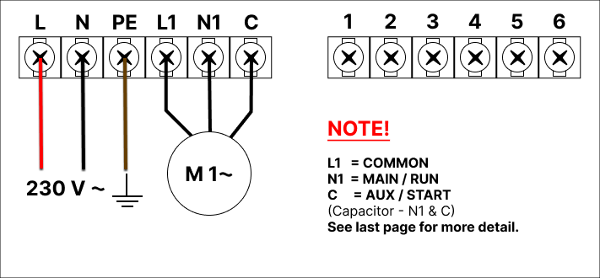
Single phase input and output wiring.

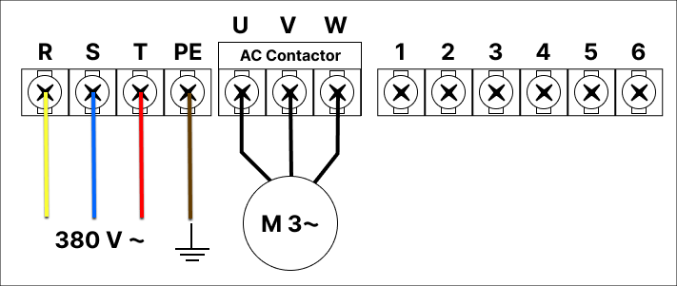
  - Three phase input and output wiring.
NOTE: Sensor terminal block can be removed for ease of connection.


SENSOR WIRING DIAGRAMS

Tank filling only. [2, 3 NC]

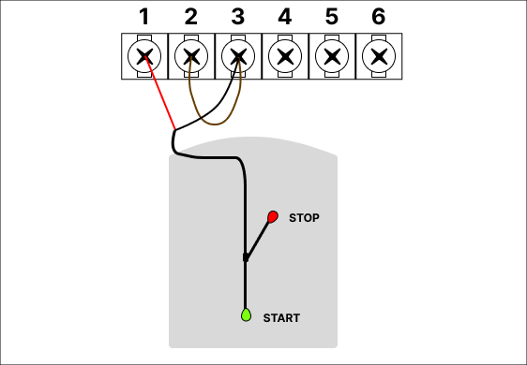
NOTE: When using only one sensor remove the bridging wires in terminals 1,2,3 and replace them with the sensor wiring.


Tank to tank. [2, 3 NC & 5, 6 NC]

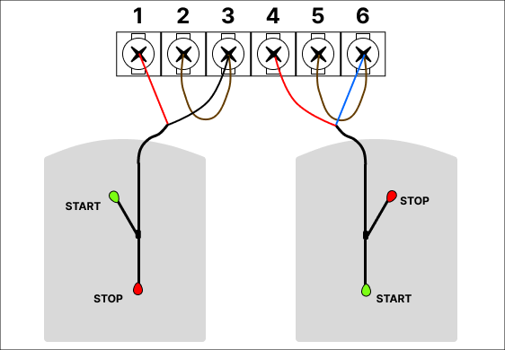


Booster pump control by pressure switch. [2,3 NC & 5 NC, 6 NO]

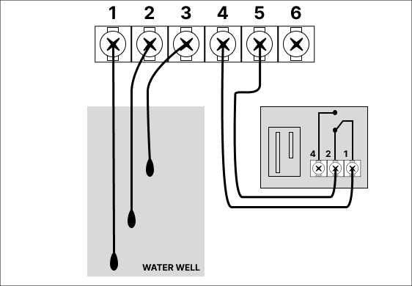
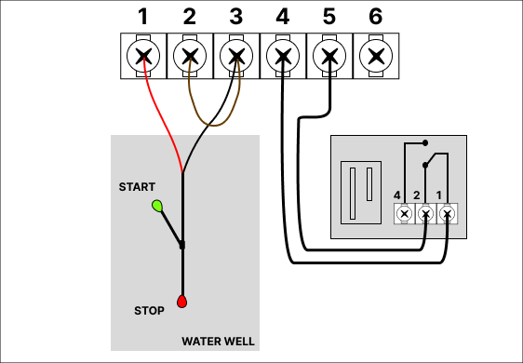

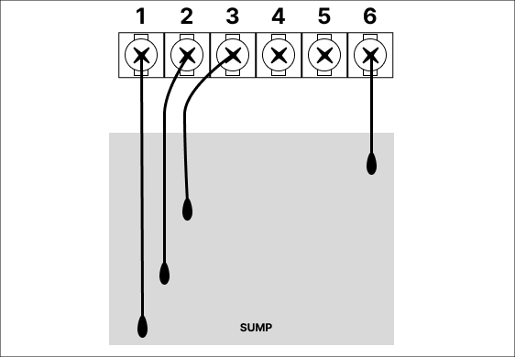
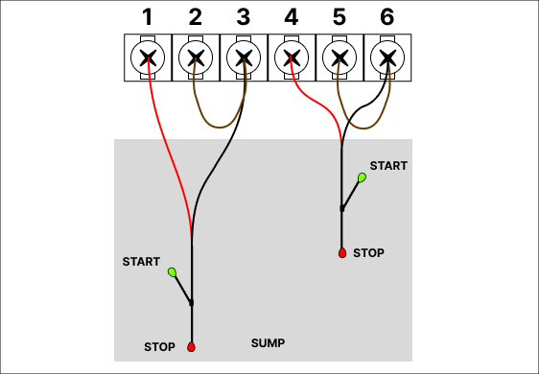
7.4 Drainage by level sensor. [2, 3 NC & 5 NO, 6 NC]


7.5 Optional temperature control.
